**SAMPLE RESULTS:**

Content Image

Style Image 1 :

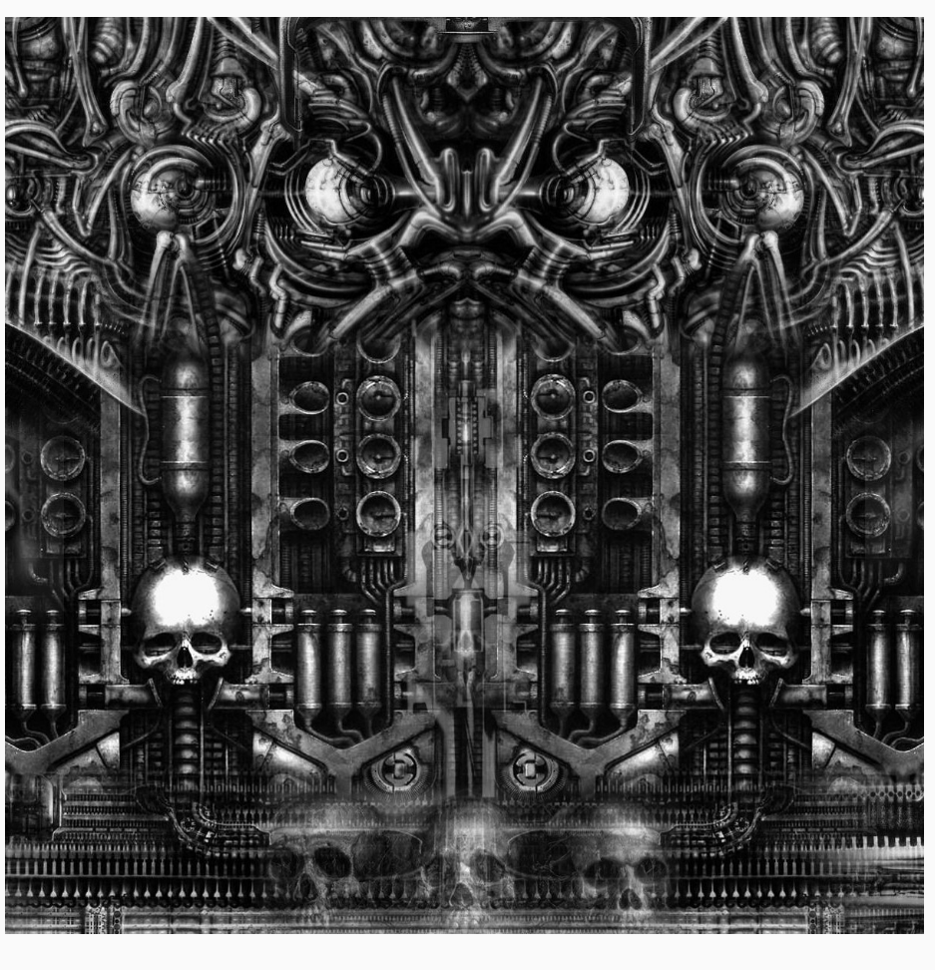

Style Image 2 : (Mosaic)

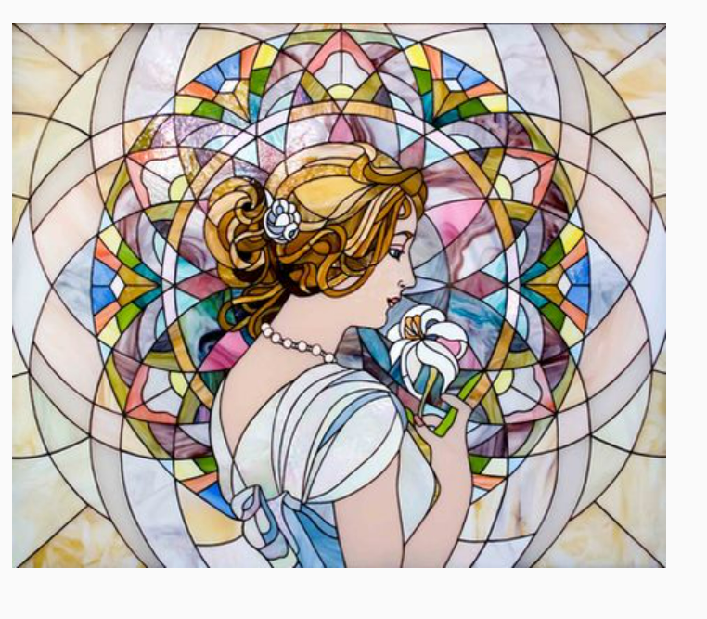

Multi-objective output :

Cascaded Output (Plain) :

Cascaded Output (Weighted) :

Varying Different Parameters :

Increasing effect of style 2

